CHRISM
CHRistians In Secular Ministry

What’s good about work?

CHRISM Conference & AGM July 19th – 21st 2019

What’s good about work? We shall be looking at what you do day by day - and how you understand this as your ministry. Come and explore the work you do day-by-day in the company of colleagues with the same objectives, relate it to theological ideas and see what it says about good work – and ministry in secular employment. Please come and join us!!

Saint Columba's House is an urban contemporary Christian retreat and conference centre just 30 minutes by train from the heart of London and a mile from the centre of Woking. Newly refurbished and with en-suite facilities, Saint Columba’s House is the venue for the Summer 2019 CHRISM conference.
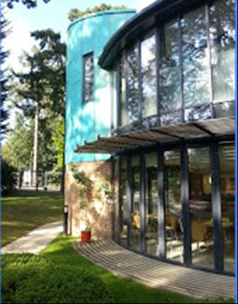

As always, our conference will include visits to places of work in the neighbourhood. Woking is a thriving centre which came into real existence with the coming of the railways. Nearby Guildford is the county’s market town. It includes the Surrey Research Park, a major centre of excellence in technology, science, health and engineering which is widely regarded as the best science park of its kind in the UK.
Join us – to find out what is good about the work we do.
………………………………………….……………………………………………………………………………
Cost, from dinner on Friday evening to lunch on Sunday, inclusive:
£190 (members); £195 (non-members). Please ask CHRISM for a receipt, if required
Ask your church for a grant to cover all or part of the cost – apply now to get their support!
Please return this slip by 5th July 2019.

Yes, I wish to attend the CHRISM Conference and AGM at Saint Columba's House, Woking, July 19-21st 2019

Name: Tel:

Address: Email:

I enclose a cheque (payable to CHRISM) for £190 (members); £195 (non-members) or a non-refundable deposit of £50
I have the following special dietary (or other) needs:
Please return to Rob Fox, 22 Queensbury Gate, Newcastle-upon-Tyne, NE12 8JW Tel: 0191 366 8048 Email: rob.fox36@gmail.com

Data protection.
The data you provide on this form will be held securely and only used to contact you about future CHRISM
events. If you do not want CHRISM to contact you in the future, please tick this box.
Visit the CHRISM Website at www.chrism.org.uk

To help ourselves and others to celebrate the presence of God and the holiness of life in our work, and to see and tell the Christian story there

